L.O. I can understand an explanation text.
Read the text and answer the questions underneath in full sentences.
How Aeroplanes Fly

Aeroplanes fly because they are able to generate a force called Lift which normally moves the aeroplane upward. Lift is generated by the forward motion of the aeroplane through the air. This motion is produced by the Thrust of the engine(s).

The figure below is a simple diagram of the four forces acting on an aeroplane – Thrust, Lift, Drag and Weight. Drag is the force produced by the resistance of the air to the forward motion of the aeroplane. Swish your hand rapidly side-to-side and you will feel that resistance on your hand.
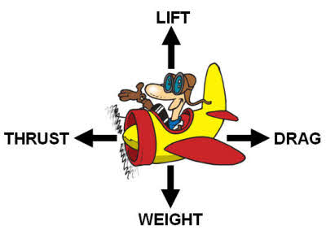
Weight is the force created by the pull of gravity toward the centre of the earth. You will feel the effect of this force if you jump up from the floor. Your weight will force you back down.

When the Thrust produced by the engine(s) is greater than the force of Drag, the aeroplane moves forward. When the forward motion is enough to produce a force of Lift that is greater than the Weight, the aeroplane moves upward. While any part of the aeroplane can produce Lift, the most Lift comes from the wing.

- How is lift generated?
- When does an aeroplane move forward?
- Why do you think the writer has chosen to put the explanation into four paragraphs?
- Why do you think the writer has put some words in bold?

L.O. I can understand an explanation text.
Read the text and answer the questions underneath in full sentences.
How Aeroplanes Fly

Aeroplanes fly because they are able to make a force called Lift which normally moves the aeroplane upward. Lift is made by the aeroplane moving forwards through the air. This happens because of the Thrust of the engine(s).

The picture below is a simple diagram of the four forces acting on an aeroplane – Thrust, Lift, Drag and Weight. Drag is the force created by the air getting in the way of the aeroplane as it moves.
Weight is the force created by the pull of gravity toward the centre of the earth. If you jump, it is your weight that brings you back down.

When the Thrust created by the engine(s) is bigger than the force of Drag, the aeroplane moves forward. When the force of Lift is bigger than the Weight, the aeroplane moves upward. While any part of the aeroplane can produce Lift, the most Lift comes from the wing.

- How is lift made?
- When does an aeroplane move forward?
- Why do you think the writer has chosen to put the explanation into four paragraphs?
- Why do you think the writer has put some words in bold?

L.O. I can understand an explanation text.
Read the text and answer the questions underneath in full sentences.
How Aeroplanes Fly

Aeroplanes fly because they are able to make a force called Lift which moves the aeroplane upward. Lift is made by the aeroplane moving forwards through the air. This happens because of the Thrust of the engine(s).

The figure below is a simple diagram of the four forces acting on an aeroplane – Thrust, Lift, Drag and Weight. Drag is the force created by the air getting in the way of the aeroplane as it moves.
Weight is the force created by the pull of gravity toward the centre of the earth. If you jump, it is your weight that brings you back down.

When the Thrust created by the engine(s) is bigger than the force of Drag, the aeroplane moves forward. When the force of Lift is bigger than the Weight, the aeroplane moves upward. While any part of the aeroplane can produce Lift, the most Lift comes from the wing.

- How is lift made?
- When does an aeroplane move forward?
- Why do you think the writer has chosen to put the explanation into four paragraphs?
- Why do you think the writer has put some words in bold?

